Assignment 4: User Research

GIT 542 User Experience and Usability

Douglas Swanson

February 8th, 2021

<https://www.spacefoundation.org/>

Survey / Interview Questions

I used a website called survey monkey to create my survey, by logging in and selecting some generic questions (for the demographic questions) and typing in some more site-specific questions. Here is the survey.

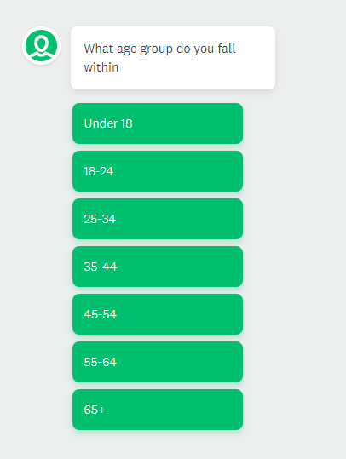

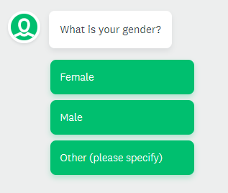

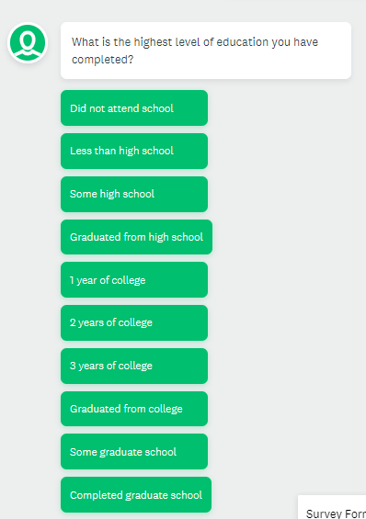

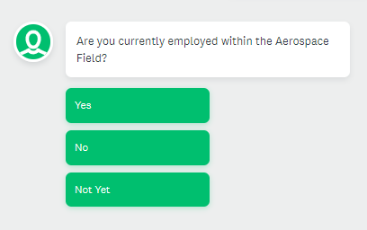

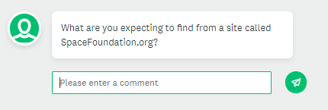

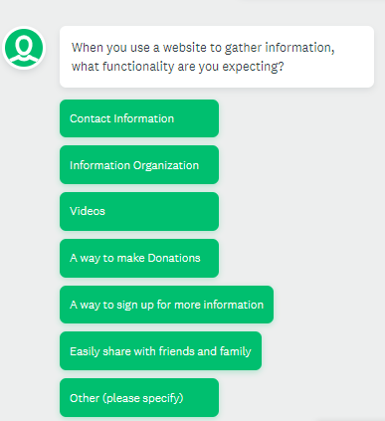

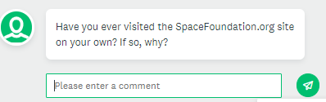

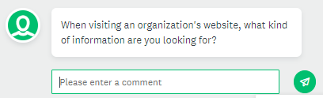

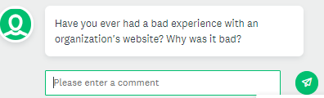

User Responses

Unfortunately, I was unable to get to this part of the assignment before the due date, I have a few interviews scheduled over the next couple of days. My apologies my wife and I are moving and have spent all week getting the house packed and ready.